Day #6 – What about competition?

Okay Eric you sold me on the idea that this is lucrative.

You showed me an overview of the process.

You convinced me that anyone could do it?

I learned that I could do it from home.

I see why the government is using private contractors.

But geez with all these advantages there must be massive competition, right?

It would be naive for me to believe that somehow everyone and their mama ain’t doing this.

Click below to find out my thoughts on the competition.

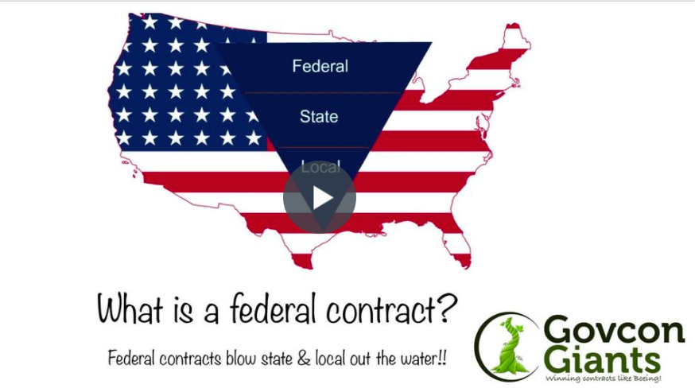

Today’s HW assignment provides confirmation that if done correctly you could be the ‘big fish’ in a little pond.
Want to find out what I mean. Tune into the lesson and do the homework.

Learn about The Competition Myth

Big hug,

Eric Coffie

